
Joint inspection of services for children at risk of harm

Case Records File Labelling Documents we read
Publication date: August 2022

Publication code 001C

Background and Purpose
The content includes a quick reference guide for services on the record labelling convention for submission of children’s and young people's records for record reading during joint inspections. The guidance offers a systematic process and consistent record labelling approach to assist an efficient review of the records of children and young people at risk of harm within the agreed sample.
- Records require to be made available remotely – that is, electronically, and without the requirement for the joint inspection team to be physically ‘on-site’ in the community planning partnership area.
- This process is subject to a Data Protection Impact Assessment (DPIA), a copy of which is available on request. We encourage partnerships to collaborate with their IT and information governance colleagues in relation to the DPIA at the earliest opportunity to support the effective sharing of information.
- Secure and efficient processes are in place that enable records to be accessed remotely by the joint inspection team and local file readers. This is achieved by either:
- placing records from the agreed sample in the partnership’s SharePoint repository, or equivalent, and allowing time-limited access to the joint inspection team, or
- uploading records from the agreed sample to the Care Inspectorate’s SharePoint repository.
It is preferred that where a partnership has their own SharePoint site, or equivalent, that this is the default repository. This ensures that the partnership retains control of data governance matters.
In this model there is an inter-dependency on the availability of partnership business support to facilitate the uploading of documents. The joint inspection team lead and strategic support officer will engage with each partnership area to outline in further detail what is required and agree an approach which best fits the requirements of each area.

Record Labelling
Records shall be labelled as:
ID_YYYY-MM-DD _Document Name
- ID
  - A unique identifier number will be used for each record prefixed by ‘S’ indicating sample, i.e., S01, S02, S03 (include 0, not S1, S2, S2). This identifying number corresponds to the record sample list specified in the Pre-Inspection Return, submitted to the Care Inspectorate.
- Date*
  - Set out in YYYY-MM-DD format.
  - e.g., Minutes = day meeting took place, Report = date the report was written, Case notes with a range of dates = YYYY-MM-DD_YYYY-MM-DD
- Document Name
  - Additional information to identify the records further. Please use consistent labels where possible

Reasons behind labelling convention as noted above:
- Using the unique ID first means it is always clear to whom the record relates and files will automatically group by the specific record (when sorting alphabetically by file name).
- Using date next in the label means, when sorted by record name, the records will group chronologically for that record.
- Underscores are used either side of each record label section, so each is clear.
- Additional Information – provides further clarity of what the record is. The suggested labels ensure consistency but allow flexibility as needed.
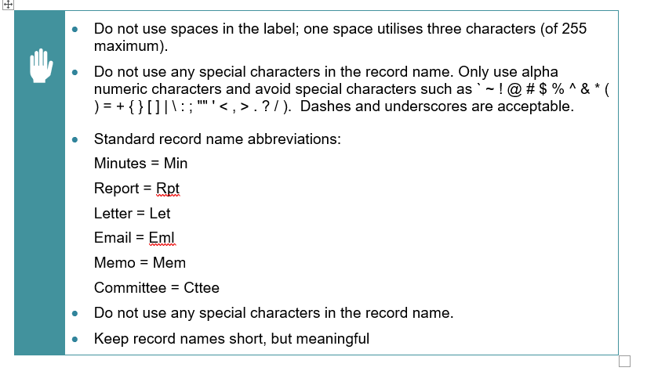

What we will read
This table outlines what documents are required for the remote record reading. Note that all material uploaded should be from within two years of the agreed date.
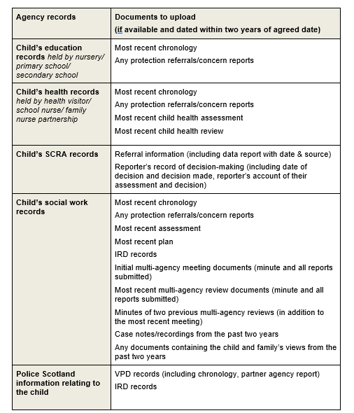

Approach to Record Management
The guidance below depicts the folder structure that will be made available for the purposes of records sharing, should partnerships not have their own data sharing platform. This is a set structure within the Care Inspectorate’s system and cannot be amended.
As noted earlier, it is preferred that where an area has their own SharePoint, or equivalent, that this is the default repository. As such, it is recommended that areas using their own data sharing platform also follow this layout:
The joint inspection team will be looking for two main folders:
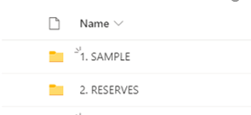
- Sample
We will require the folders to be created and named S01 – S60. In here you will put all documents relating to the identified records to be read from the agreed sample.

- Reserve (This will be the reserve records if applicable) We will require the folders to be created and named R01 – R15.

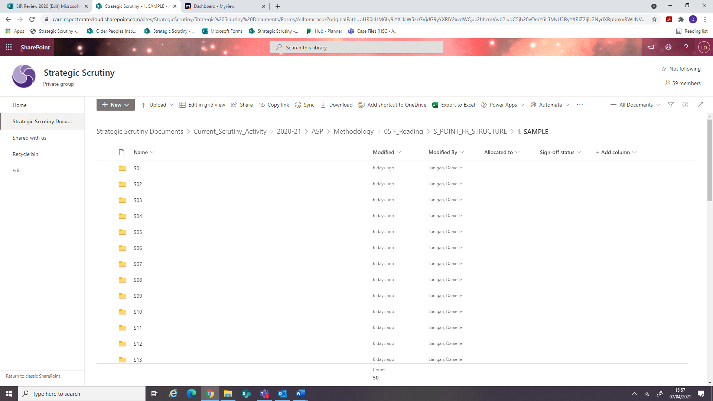
- Areas will be given a unique case identifier for each of the records to be read S01 – S60.
- The sample will also include a reserve list which will be given a unique case identifier R01-R15.
- Within each folder there should be a separate folder for social work, health and education records.
- All records should be uploaded in pdf format.
- Upload records into the SharePoint folder (or as agreed) using the agreed naming convention as per section 3.
- If there are any queries or difficulties, strategic support officers will be available to assist.

Records from SCRA and Police Scotland
Following a national agreement, Police Scotland will liaise with HMICS to upload records for children and young people at risk of harm to Egress.
SCRA will upload records for children and young people at risk of harm to the Care Inspectorate Sharepoint site.

Headquarters
Care Inspectorate
Compass House
11 Riverside Drive
Dundee
DD1 4NY

web: www.careinspectorate.com
email: enquiries@careinspectorate.com
telephone: 0345 600 9527

@careinspect

Other languages and formats


Copyright of Care Inspectorate 2022 

