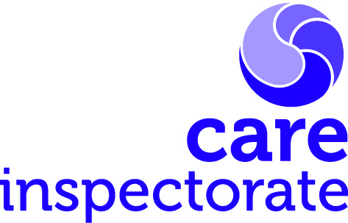Care Inspectorate self-evaluation tool

How good is our care and support during the COVID-19 pandemic?

Use this tool alongside the ‘Operating an early learning and childcare setting (including out of school care and childminders) during COVID-19’ and our guide to self-evaluation for improvement. It can help you self-evaluate and plan for improvement.

The text boxes will expand automatically as you type.

Please do not return your completed self-evaluation tool to us until requested. Inspectors will request the completed document from providers on a risk and sampling basis. However, we may undertake other scrutiny activities in settings.

Name of service:

Manager:

Children’s health and wellbeing
Quality Indicator 5.1: Children’s health and wellbeing are supported and safeguarded during the COVID-19 pandemic.

How are we doing?
This is the key to knowing whether you are doing the right things. How are children nurtured and supported throughout their changed experience in the early learning and childcare setting? What is the effective communication with families enabling responsive care to support to children through the changing circumstances?

How do we know?
Answer this question with robust evidence. The quality indicator, along with the views of staff children, and their families can help you evaluate how you are doing. You should also take account of performance data collected by your setting

What are we going to do now?
Understanding how well your setting is performing should help you see what is working well and what needs to be improved. From that, you should be able to develop and prioritise plans for improvement.

Include the actions, the timeline, and who will carry them out.

Infection prevention and control
Quality indicator 5.2: Infection prevention and control practices support a safe environment for children and staff.
How are we doing?
This is the key to knowing whether you are doing the right things and that, as a result, children are protected as staff take all necessary precautions to prevent the spread of infection.

How do we know?
Answer this question with robust evidence. The quality indicator, along with the views of staff, children and their families can help you evaluate how you are doing. You should also take account of performance data collected by your service.

What are we going to do now?
Understanding how well your setting is performing should help you see what is working well and what needs to be improved. From that, you should be able to develop and prioritise plans for improvement.

Include the actions, the timeline, and who will carry them out.

Staffing arrangements
Quality indicator 5.3: Staffing arrangements are responsive to the changing needs of children during COVID-19. (Not applicable to childminding services who do not employ assistants.)
How are we doing? What is our evaluation of performance?
This is the key to knowing whether you are doing the right things. How are staffing arrangements meeting the needs of children and families? How are staff supported to be confident?

How do we know?
Answer this question with robust evidence. The quality indicator, along with the views of staff, children, and their families can help you evaluate how you are doing. You should also take account of performance data collected by your setting

What are we going to do now?
Understanding how well your setting is performing should help you see what is working well and what needs to be improved. From that, you should be able to develop and prioritise plans for improvement.

Include the actions, the timeline, and who will carry them out.

