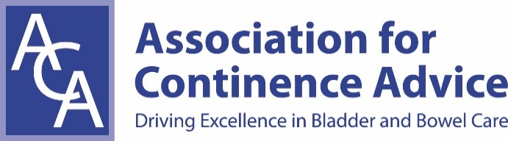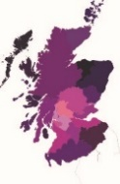
ACA Scotland Study Day: Whose Urethra is it?
September 1st 2017, DEWARS CENTRE
Delegate Registration Form and Payment Instructions
First Name: ………………………………………………….. Surname: …………………………………………………
ACA Membership No (if applicable): ……………………………………………………..
Job Title: ………………………………………………. Place of Work: ……………………………………………………
Email Address: ……………………………………………………………………………………………………………………
Telephone Number: …………………………………………………………………………………….
Correspondence Address: …………………………………………………………………………………………………
……………………………………………………………………………………………………………………………………………
Postcode: ………………………………..
Please tick appropriate boxes below:
Non Member Study Day Fee only £25.00 | Cheque | BACS | Confirmed (office use only):
Member Study Day - free | Please tick | Confirmed (office use only):
Email Registration Form to: kate.boyce54@gmail.com
Please make cheques payable to ACA General (write ‘Scotland 01/9’ on the back) and send to:
Brian Young, ACA Scotland Treasurer, 1 Temple Mains Steading, Innerwick, EH42 1EF
BACS payments: Account No: 10522837 Sort Code: 83 51 00
Reference: ScotSepSD

