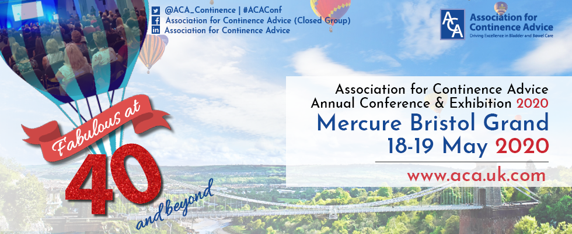

Delegate registration now open for
Association for Continence Advice (ACA)
Annual Conference and Exhibition 2020
18th and 19th May 2020
Mercure Bristol Grand Hotel
www.aca.uk.com/conference
We are delighted to announce that the Association for Continence Advice (ACA) Annual Conference and Exhibition will be held on the 18th and 19th May 2020 at the Mercure Bristol Grand in Hotel and registration is now open. This year's conference: ‘Fabulous at 40 and beyond’ will celebrate 40 years of ACA, looking back at how far we have come and forward to what lies ahead for our profession, and we hope you can join us to celebrate this joyous occasion.
Who should attend?
The conference will be of interest to Continence Advisors, Continence Nurses, Physiotherapists, Urology Nurses, and Specialist Nurses as well as doctors or allied healthcare professionals working within, or interested in continence care.
There will also be an extensive company exhibition offering new innovative products and practical solutions in the field of continence care.

ACA members will receive 20% off their conference place if they register before Friday 20th March
Not yet a member? – Join here: www.aca.uk.com/join-us

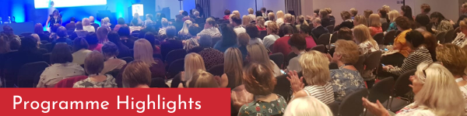
Programme Highlights
The comprehensive programme has been designed based on the feedback you provided from 2019 and will include the following topics:
- 40 years of the ACA
- Continence Advisors are Awesome:
Dame Yvonne Moores (Keynote speaker on Monday 18th May)
- The National Bladder and Bowel Health Project:
Sue Doheny (Keynote speaker on Tuesday 19th May)
- Bowel Problems in People with Learning Disabilities
- Bladder Training App for Young People
- Advances in the Uses of Robotics with the Pelvic Floor
- The Future of Virtual ACA Branches
- Physical/Medical Aspects of Sexuality and Continence
- The Impact of Continence Issues on the Individual, Relationships and Intimacy
- Medication and the Link to the Bladder
- ...and much more!
We are continually working on the programme to ensure it covers all the contemporary issues in continence care so please keep an eye on our website and future emails for any updates.

Free Paper and Poster Entries
There are plenty of opportunities for you to contribute to this year's programme.
Have you ever thought about submitting an abstract for a free paper or a poster presentation? By presenting your information at conference you are helping to educate and inspire others in your field of expertise and you could win up to £250!
This is your opportunity to be part of conference so simply visit the website by following this link
www.aca.uk.com/conference/abstracts for an easy step-by-step submission process.
Abstract for free paper and poster submission deadlines: Monday 23rd March 2020

The Dorothy Mandelstam Award 2020
The Dorothy Mandelstam award is an annual award of up to £1000, to cover conference costs and a personal prize. It acknowledges the pioneering continence work of Dorothy, who was a founding member of the ACA.
To apply each applicant needs to provide a 2,000 word paper on a continence service development that improves the quality of patient care or a 2,000 word case study on a chosen aspect of continence care.
All applications must be submitted by Friday 29th February 2020. The winner will present their work at the ACA Annual Conference on 18th - 19th May in Bristol.
For more information and to apply visit www.aca.uk.com/education/awards

