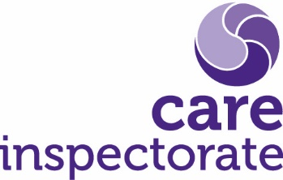
Joint inspection of services for children at risk of harm

Position statement guidance

Publication date: March 2022

Publication code: 003
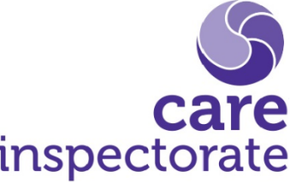

Joint Inspection of services for children at risk of harm

Guidance on the submission of the community planning partnership’s position statement

In light of the Covid-19 pandemic, the Care Inspectorate with scrutiny partners agreed a revised programme of inspection focussed on children at risk of harm. Inspections take account of the experiences and outcomes for children at risk of harm with consideration given to the wider context of work and the continuation of practice to keep children and young people safe.

Looking ahead to the full implementation of The Promise and the changes that will be required in both practice and scrutiny, the intention of this methodology is to achieve assurances about how children and young people at risk of harm are being kept safe by protection processes which staff use to identify, assess and plan for the management of that risk. We are keen to establish how well processes are being used to enable children and young people to experience sustained loving and nurturing relationships to keep them safe from further harm and promote their well-being.

The submission of a position statement from community planning partnerships (CPPs) which outlines their joint practice relating to children at risk of harm will provide the inspection team with valuable evidence and will be used to identify and prioritise areas of practice which would benefit from further scrutiny.

A strong position statement will be informed by the CPP’s self-evaluation activity relating to how protection services/processes which identify and lessen the risk of harm are delivered. We will also expect information about their impact and the views of children, young people and families’ and experience of the help they receive. The Care Inspectorate ‘Quality framework for children and young people in need of care and protection November 2022’ will be central to the development of your position statement.

Our inspections will provide independent scrutiny and assurance that children and young people at risk of harm are protected, safe and supported. We will consider the extent to which children and young people are safer because they have received the right help at the right time to reduce risks. We will consider how the partnership has prioritised nurturing relationships to ensure children and young people experience a loving and stable home environment.

We will report on the extent to which partnerships demonstrate that:

- Children and young people are safer because risks have been identified early and responded to effectively.
- Children and young people’s lives improve with high quality planning and support, ensuring they experience sustained loving and nurturing relationships to keep them safe from further harm.
- Children, young people, and families are meaningfully and appropriately involved in decisions about their lives. They influence service planning, delivery and improvement
- Collaborative strategic leadership, planning and operational management ensure high standards of service delivery.

Inspectors will use the range of quality indicators but will put particular focus on the following to establish the standard and quality of practice by reviewing. We will evaluate 2.1.

2.1 Impact on children and young people.
2.2 Impact on families; and
5s Delivery of key processes
6.2 Planning and improving services
6.4 Performance management and quality assurance
8.1 Management of resources
9.2 Leadership of strategy and direction

Preparing the position statement

The position statement should be presented under the following headings and focus on children and young people at risk of harm.

- Context of children’s services
- What your data is telling you
- Children and young people’s involvement and feedback
- Quality Assurance and evaluative activity
- Collaborative strategic and operational leadership
- 3-5 key achievements and areas for improvement

The position statement will present a coherent picture of performance, practice and leadership across the partnership as it currently stands.

It should focus on the impact of your work with children and young people at risk of harm, the difference that your work is making to their life chances and how you know.

We ask that your position statement is no more than 5,000 words and is presented in the format you find most useful. Please ensure links to your evidence are clearly marked throughout the document.

The quality framework provides details of all 22 quality indicators and partnerships may wish to focus on particular quality indicators or aspects of these to support their submission in addition to the key QIs listed above.

Content of the position statement

Context of services for children and young people at risk of harm

Please provide a brief description of the context within which children’s services are being delivered within your area. This need not be overly detailed as inspectors will have oversight of the partnership’s children’s service plan and other publicly accessible documents as part of the preparation for inspection.

Please outline the governance arrangements for child protection in the partnership in this section, including links to other boards and strategic oversight.

What your data is telling you

CPPs will use this section to demonstrate the difference that services are making to the lives of at risk children, young people and families based on information relating to outcomes, performance, and trends. The emphasis should be on the tangible results partners are achieving in relation to keeping children and young people safe. Use the data, performance indicators and information you routinely use as the basis of your analysis and be guided by quality indicator 1.1. Any links you can make to QI 6.4 (performance management and quality assurance) will be useful. This will provide a focus on how your partnership has applied performance management and quality assurance frameworks to ensure consistency in delivering high standards of service and improved outcomes for children and young people.

Children and young people’s involvement and feedback

We want to hear about your approach to involving children and young people in all the stages of protection processes and the impact this has had. This is an opportunity to outline your strategic and operational approaches to involving children and young people in key processes and to explain how you gather feedback and what you do with the information you receive. We are interested to see how you enable children and young people to take part in discussions about service delivery and improvement and how you respond to their views. We want to know about information sharing and complaints processes and will be seeking assurance that these are accessible and actively promoted. This will be the place to tell us how you comply with the broader remit of the UNCRC and your localised implementation to children’s rights issues.

Collaborative strategic and operational leadership

This section provides an opportunity to outline arrangements for leadership both at a strategic and operational level across the partnership and the impact these arrangements have on children at risk of harm. It will link to the opening section of the position statement on the context of services for children, young people and families at risk of harm.

In this methodology we will be focussing on what quality indicator 6.2 (planning and improving services) tells us about leadership along with 9.2 (leadership of strategy and direction). We want to be assured of how children’s services planning arrangements, including child protection committee and business planning are leading to improved outcomes for children and young people. We want to see how plans reflect the partnership’s strategic priorities for child protection and demonstrate a commitment to a rights-based approach. We need to understand how you manage and mitigate emerging risks to children and young people, whilst ensuring they experience sustained loving and nurturing relationships to keep them safe from further harm. This will have a direct correlation to understanding how you have been able to respond to the Covid-19 pandemic.

While 6.2 and 9.2 will be our focus, the quality indicators 9.1-9.4 which focus on the commitment and effectiveness of leaders and how collaborative leadership plans and directs the delivery of services, will inform your submission.

Quality Assurance and evaluative activity

Quality assurance and self-evaluation activities contribute to performance management to ensure high standards of service delivery and improved outcomes for children and young people. This section will help us to understand your performance framework and the agreed set of standards and outcome indicators and how senior leaders oversee this. We want to understand how children’s service partners routinely identify best practice and improvement areas are identified and addressed. This section will be an opportunity to highlight your approach to continual improvement. It is useful to hear about any audits which have been completed and how practice has developed as a result. As with all sections of the position statement, we will be looking for any relevant information on your involvement of children, young people and families and how you have used feedback to help improve services.

Key achievements

In this section, we ask you to tell us about three to five key achievements over the last two years which have had the most positive impact on children and young people in need of protection. The Covid-19 pandemic, alongside presenting considerable challenges, also enabled partnerships to demonstrate some of their best practice so we would still welcome hearing about any examples which have impacted on your ongoing practice.

Areas for improvement

In the final section of the report, we ask you to identify your priority areas for improvement over the next three years. We also ask you to comment on your capacity for improvement which should be informed by quality indicator 10 within the quality framework.

Evidence to support position statement

To be robust and reliable, you should use a range of sources of evidence to ‘triangulate’ or support your position. Inspectors will review the supporting evidence, validate its robustness, and use it to scope the next stages of the inspection and identify areas for further discussion with partners.

Submission of documentary evidence

Core documents that are required by the inspection team are outlined in appendix 2. These should be current strategic documents and other documents which provide evidence of outcomes which inform and support your overall position statement. There must be a clear link between statements in the position statement and the supporting evidence provided.

To reduce the impact of inspection on partnerships and to ensure that inspectors are sighted on the most relevant and appropriate supporting evidence, partnerships should submit only their strongest sources of evidence and the most recent version of each document. Partnerships can consider further supporting evidence they wish to draw on to inform their position statement additional to these core documents, but we do stress that quality and currency are more important than quantity and this should only be done as an exception.

Evidence should be clearly referenced in the position statement document. We also ask for a separate document log which collates all the evidence that you have referenced. When completing the document log please ensure that you provide a document number as well as the document name.

Where documents are publicly available, provide a hyperlink rather than to the document itself. Links to websites should be referenced within the document log. A Strategic Support Officer can provide more detail about this as necessary.

Inspectors will review your position statement, core documents and supporting evidence in advance of onsite inspection activity.

A submission date for your position statement, document log and supporting evidence will be provided.

In accordance with GDPR please ensure that your supporting evidence does not contain any personal or identifiable information.
The Care Inspectorate is committed to protecting the privacy of the people whose personal information we hold and to meeting our data protection obligations under the General Data Protection Regulation and UK Data Protection Act 2018. More information can be found in our Privacy Notice on the home page of our website at www.careinspectorate.com.

Appendix 2: Core document request

- Health and Social Care Partnership/Integration Joint Board (where children’s services are delegated to the IJB) annual report

- Performance framework (or equivalent) – children’s services

- Multi-agency governance arrangements for protection

- The previous four data set reports to the CPC

- Recent audit reports

- Child protection committee plan and annual report

- The previous four sets of minutes of the Chief Officer’s group, the child protection committee

- Children’s services plan and progress updates

- Strategic needs assessment for children’s services

- Results of any large surveys of the views of children, young people and families

- Chief social work officer’s report

- Quality assurance/self-evaluation framework or equivalent

- Local poverty action plan

Headquarters
Care Inspectorate
Compass House
11 Riverside Drive
Dundee
DD1 4NY

web: www.careinspectorate.com
email: enquiries@careinspectorate.com
telephone: 0345 600 9527

@careinspect

Other languages and formats
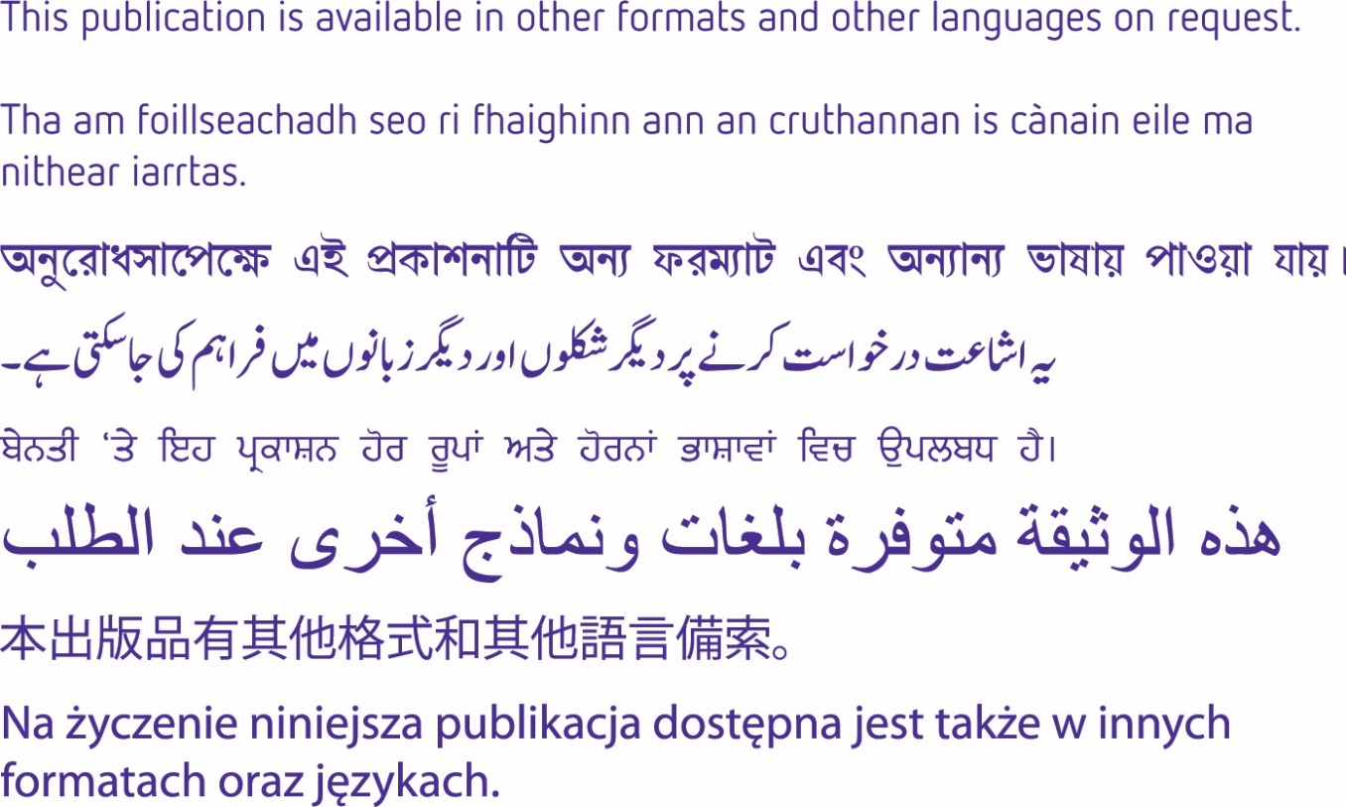

Copyright of Care Inspectorate 2023 