Joint inspection of services for children at risk of harm

Pre-inspection return

Publication date: November 2021

Publication code: 001b

Pre-inspection return
Please note this is an exemplar and an excel template will be issued to each partnership for completion.

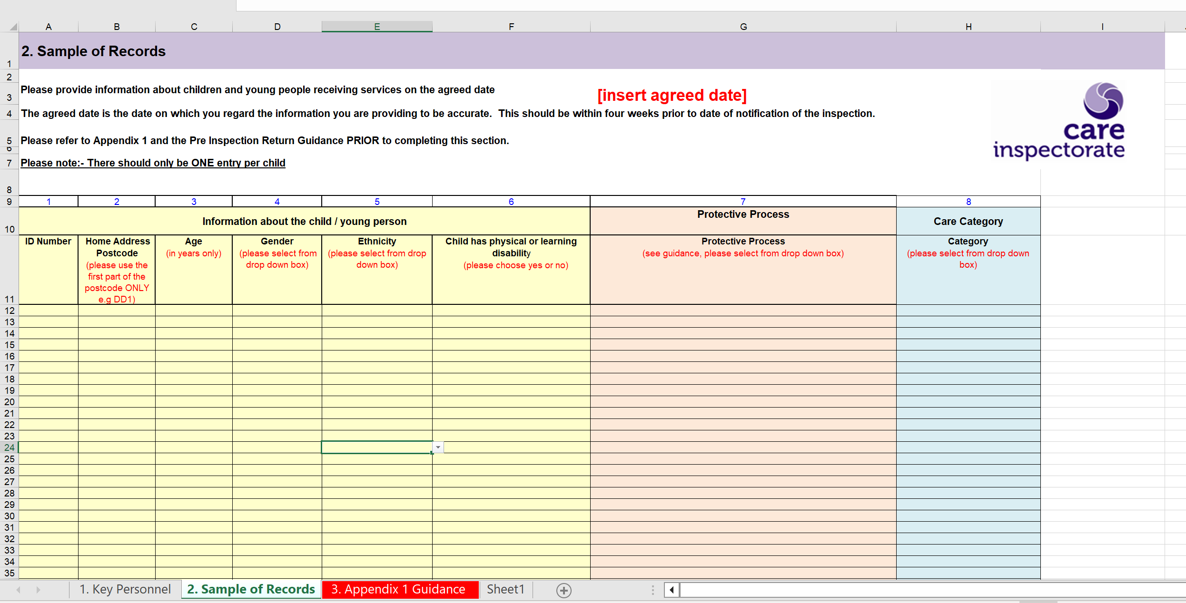

 | Appendix 1: Guidance for completing Section 2. Sample of records
 |  |  | Column
Information about the child / young person | ID number | Please provide each child with a unique identifying number. If possible, please try to make this number as simple as possible using numerals only | 1
 | Child’s home address | Use first part of postcode only eg EH51 or IV6. This is to adhere to privacy arrangements and preserve anonymity. | 2
 | Age | Use number of years only. Do not include months. If child is less than one year, record as 0. | 3
 | Gender | Please select ONE of the following from the drop-down box  • Male  • Female  • Trans man  • Trans woman  • Non- binary  • Other  • Refused | 4
 | Ethnicity | Please select ONE of the following from the drop-down box | 5
 |  | White UK
 |  | White Irish
 |  | White Other
 |  | Asian Bangladeshi
 |  | Asian Chinese
 |  | Asian Indian
 |  | Asian Pakistani
 |  | Asian Other
 |  | Black African
 |  | Black Caribbean
 |  | Black Other
 |  | Gypsy Traveller
 |  | Mixed
 |  | Other Ethnic Background
 |  | Not Disclosed
 | Child has physical or learning disability | Please select YES/NO as applies at AGREED DATE:  (For this category we ask for those children and young people that the local authority define as having a disability in line with the children (Scotland) Act 1995, Section 23(2): For the purposes of this Chapter of this Part a person is disabled if he is chronically sick or disabled or suffers from mental disorder (within the meaning of the Mental Health (Scotland) Act 2015) | 6
Protective process |  | Please select ONE of the following from the drop-down box.  NB: If the child has been subject to more than one protective process within the past two years, select the category based on the most recent event or intervention. | 7
 |  | Children who have been subject to a child protection investigation and this has not led to child protection registration. This includes instances were child protection involvement has ended at the IRD, investigation or child protection planning meeting (previously initial child protection case conference). This excludes instances when concerns have been reported for children, but these have not led to the commencement of a child protection investigation.
 |  | Child’s name placed on the child protection register
 |  | Involvement in care and risk management processes (or equivalent process)
 |  | Involvement in vulnerable young person’s processes (or equivalent process)
Care category |  | Please select ONE of the following from the drop-down box | 8
 |  | Not looked after
 |  | Looked after at home
 |  | Looked after away from home
 |  | Continuing Care
 |  | After care
Data Protection Statement
The Care Inspectorate will process (including collect, use, store, disclose) personal information on computer and paper files for the purpose of carrying out its functions under the Public Services Reform (Scotland) Act 2010 and associated regulations in accordance with the Data Protection Act 2018 and Article 8 of the Human Rights Act . Information will not be disclosed unless it is lawful for the Care Inspectorate to do so. More information can be found in our Privacy Notice on the home page of our website at www.careinspectorate.com.
In accordance with the minimisation principle (7) of the Data Protection Act 2018 and the GDPR, you must ensure the personal data you are sending the Care Inspectorate is:
a) adequate – sufficient to properly fulfil our stated purpose;
b) relevant – has a link to that purpose; and
c) limited to what is necessary – for example, strategic inspections do not require personal identifiers.
If you send us personal material over and above that which is required it may constitute a data breach for your organisation, and in a worst case scenario, be reportable to the Information Commissioner.

Headquarters
Care Inspectorate
Compass House
11 Riverside Drive
Dundee
DD1 4NY

web: www.careinspectorate.com
email: enquiries@careinspectorate.com
telephone: 0345 600 9527

@careinspect

Other languages and formats

Copyright of Care Inspectorate 2023

