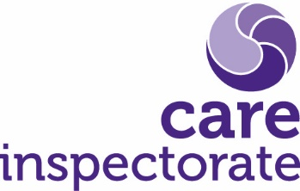
Joint inspection of services for children at risk of harm

Pre-inspection return guidance

Publication date: August 2022

Publication code 001a

Joint Inspection of services for children at risk of harm

Pre-inspection return guidance
Following notification of the inspection, the partnership is asked to complete a pre-inspection return by a specified date. This pre-inspection return enables the inspection team to be aware of:
- The key personnel within the partnership area
- Information about children involved in protective processes on an agreed date and from which a sample of records can be drawn for review.

Within the pre-inspection return we ask that you identify an agreed date on which you regard the information that you are providing to be accurate. This date should be within four weeks prior to the notification of the inspection. We read children’s records as far back as two years prior to this agreed date.

The sample should list all children (including unborn babies, children and young people under the age of 18) who have been involved in at least one protective process within two years of the agreed date. This includes:

- Children who have been subject to a child protection investigation and this has not led to child protection registration. This includes instances where child protection involvement has ended at the initial referral discussion, investigation or child protection planning meeting (previously known as the initial child protection case conference). This excludes instances where concerns have been reported for children, but these have not led to the commencement of a child protection investigation.
- Children whose names have been placed on the child protection register.
- Children involved in vulnerable young person’s processes (or equivalent protective process, varying nationally)
- Children involved in care and risk management processes (or equivalent process, varying nationally)

Note that there may be a small number of young people (age 16 and 17) who are subject to adult support and protection processes. This joint inspection will not review adult support and protection records. However, if the same young person has been involved in any of the other protective processes listed (for example if the young person has been subject to an IRD), then they should be included in the sample.

If a child has been involved in more than one protective process within the past two years, only record their details once.

Should you have any questions regarding the sample or the completion of the pre-inspection return, contact the inspection lead and/ or strategic support officer at the earliest opportunity.

Following the completion of the pre-inspection return, the Care Inspectorate will select a representative stratified sample of 60 records and a further 15 reserve records of children at risk of harm. The sample will be chosen independently and at random by the intelligence team, therefore reducing any bias. We will then ask you to provide education, health, social work, police, and SCRA records (if relevant) for those that have been selected for review. We will then work with you to make arrangements for uploading documents to a secure data sharing platform.

In addition to identifying the sample of children’s records for review, we will use the PIR to help us identify individual children, young people and their parents or carers that we would like to meet with, or hear their views through a survey.

The following flowchart outlines the process for sampling and reading children’s records.

Headquarters
Care Inspectorate
Compass House
11 Riverside Drive
Dundee
DD1 4NY

web: www.careinspectorate.com
email: enquiries@careinspectorate.com
telephone: 0345 600 9527

@careinspect

Other languages and formats
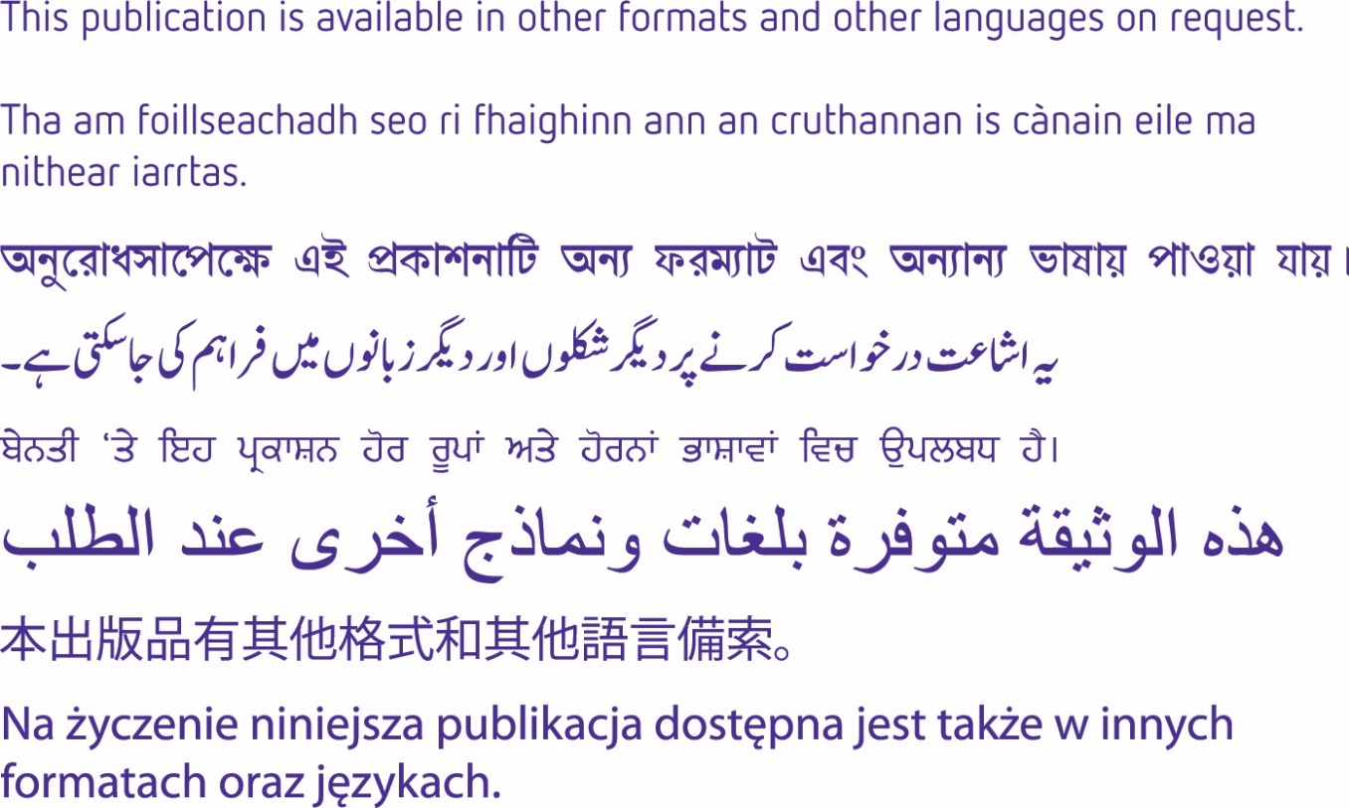

Copyright of Care Inspectorate 2023 