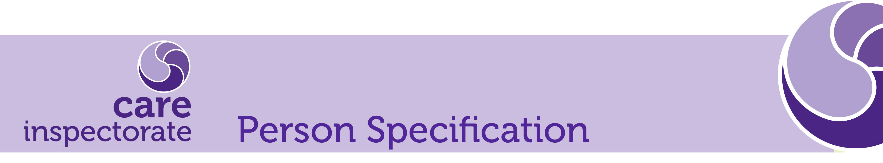

Job Title: Scrum Master – Agile Team (Temporary) Grade 8

Attributes | Essential | Desirable
Experience | - Minimum 2yrs experience in Agile methodologies and working practices  - Minimum 3yrs management/supervisory experience in a similar role.  - Experience of working with Product Owners and business managers  - Experience in creating, refining and managing product backlogs  - Experience of bringing products from inception to production.  - Exposure in software development across the entire software development cycle, using a variety of software design patterns  - Experience in developing continuous integration and deployment solutions  - Experience of engaging with staff and external stakeholders at all levels.  - Understand the value of metrics and incremental delivery. | - Experience of working with other regulatory bodies or partner scrutiny bodies.  - Experience of the NES Platform- Turas  - Experience in Microsoft.Net framework and web development, including HTML, JavaScript and MVC.
Education, Qualifications & Training | - Educated to Degree level or equivalent relevant experience  - Scrum certified
Skills & Knowledge | - Knowledge about tasks, backlog tracking, burndown metrics, velocity, user stories etc  - Knowledge about other delivery methodologies other than Agile-Scrum, so that you can explain other methodologies to motivate others  - Ability to ensure Agile/Scrum concepts and principles are adhered to and be a voice of reason and authority.  - User story writing and training  - Facilitating agile ceremonies  - Excellent customer service skills.  - Ability to work under pressure and meet targets.  - Ability to work at a high level of accuracy.  - Ability to develop initiatives to enhance support to internal and external customers | - Agile coaching  - Exposure of cloud architecture and technologies

Competencies/Key Performance Outcomes | Description
Leading others / Team Working | - Ability to provide leadership, a clear sense of purpose and direction  - Ability to deploy staff and other resources effectively to achieve performance objectives.  - Adapts to the team and builds team spirit.  - Listens, consults others and communicates proactively.  - Demonstrates integrity.  - Contributes to the shared vision and purpose and shares this effectively.  - Involves the team in decision and actions.
Effective Communication | - Listens to, understands and communicates complex and multi-stranded information from a range of sources, adopting effective questioning techniques to elicit and appreciate a range of views.  - Respond constructively and confidently to queries and complaints, negotiating with others in a way that suits the situation, demonstrating a high level of theoretical and practical knowledge.  - Ability to express ideas clearly and concisely, explain intricate and complicated concepts and ideas and adapts communication to suit different audiences.  - Ability to form constructive working relationships with people at all levels in the organisation.  - Articulate and positive communicator on a one to one basis and in larger groups.  - Regularly communicates with and ensures they are accessible to their team.
Objective Decision Making | - Demonstrates analytical and systematic approach to problem solving and decision making.  - Ensures the Agile Team has the appropriate support, resources and authority levels to make decision quickly and easily.  - Encourages and supports decisions of team members.  - Considers Care Inspectorate values in relation to the impact of their decisions and considers the wider context in which the Care Inspectorate operates.
Planning & Organising | - Ability to plan, execute, track and report on delivery progress against requirements  - Regularly reviews workloads, goals and targets with team and prioritise where necessary.  - Uses 1-1 supervision to support team members to plan workloads.  - Delegates effectively to others and optimises resources to achieve desired results.  - Focuses on customer needs and satisfaction.  - Sets high standards for quality and quantity and monitors and maintains quality and productivity.  - Works in a systematic, methodical and orderly way.
Flexibility | - Encourages a flexible, positive approach to work in their team.  - Applies rules and procedures sensibly and understands where flexibility is required.  - Works productively in a high pressure environment.  - Adapts to changing circumstances.  - Accepts new ideas and change initiatives.  - Adapts interpersonal style to suit different people or situations.
Improvement Focus | - Demonstrate innovation, advanced problem solving and mastery of methods and approaches in complex and specialised areas of work.  - Ability to identify gaps in performance and make appropriate suggestions for improvement.  - Ability to use knowledge and experience to gather and consolidate information to make appropriate improvements.  - Demonstrate initiative, drive and determination to complete tasks and achieve objectives.

Please note – these are key performance outcomes to be used to recruit into the role.

