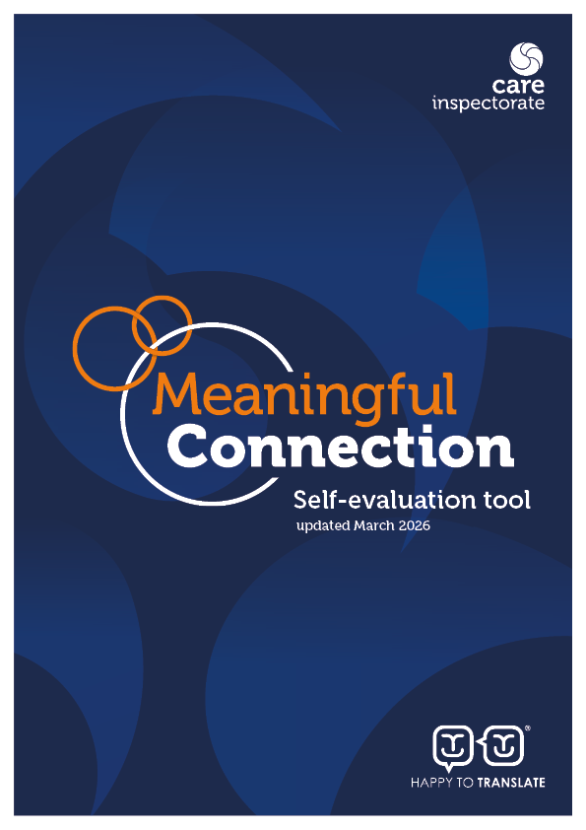
Self-evaluation tool: Meaningful connection in care homes
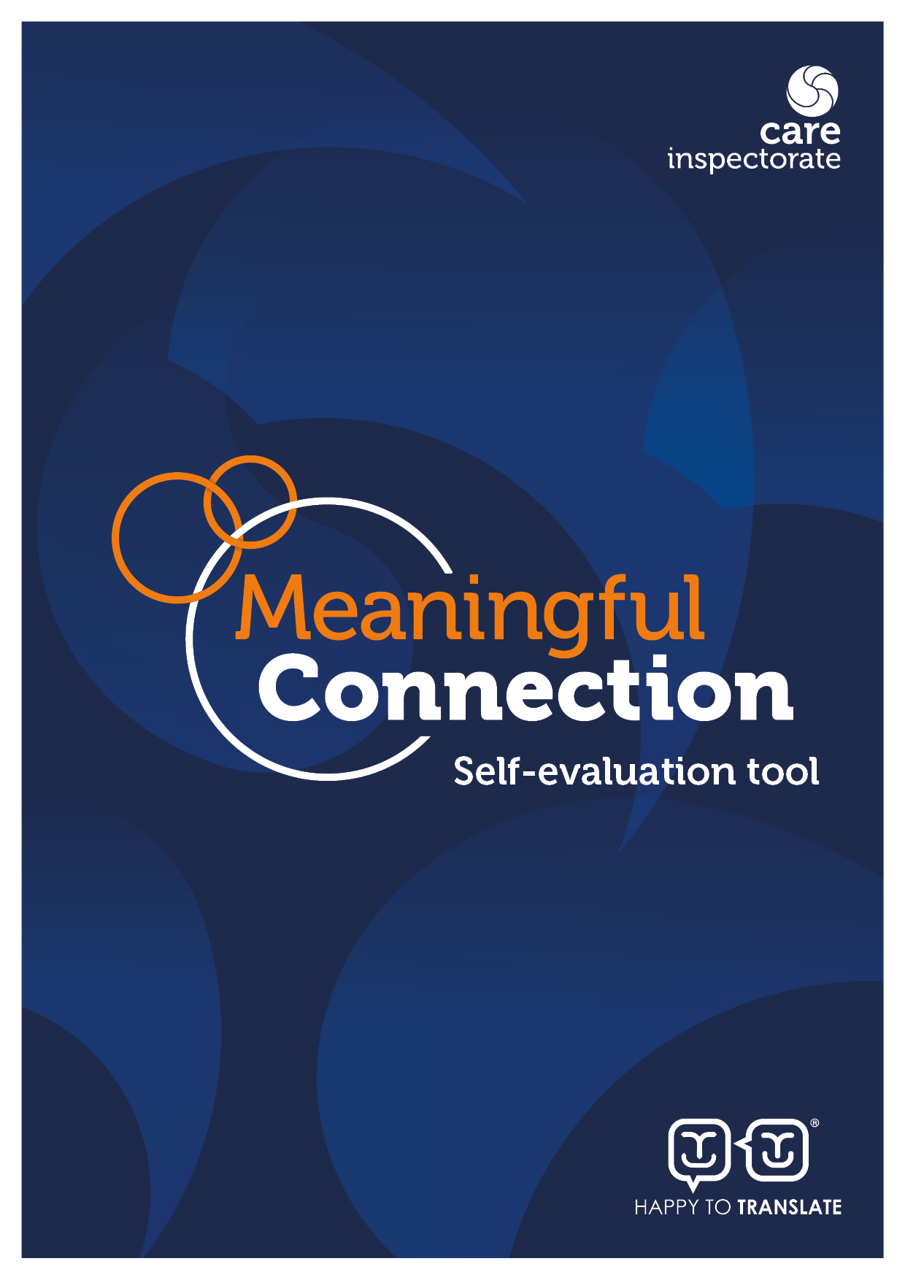
Introduction

This tool will help you to evaluate how effectively you support meaningful connection for people living in adult and older people’s care homes and identify any areas where you want to improve. See Appendix 2 for links to resources to support this work.

Meaningful connection – which may include connection with families and friends, other people living in the care home, staff, and the wider community - is essential to emotional, mental and physical health and wellbeing. It is also a fundamental human right (Appendix 2), central to dignity, identity and personhood. Maintaining relationships and community links is integral to good care and support.

This tool is designed to support you in your commitment to uphold and promote the rights, choices and social needs of people who live in care homes. At times, such as during outbreaks of infectious disease, services may need to consider whether any restrictions on connection are necessary. In these situations, decisions must be proportionate, regularly reviewed, and in line with legislation and guidance. People’s rights, independence and relationships should remain central to planning and practice.

The principles of this tool align with the expectations set out through Anne’s Law, which strengthens the rights of people living in care homes to maintain meaningful contact with those who matter to them, including through the identification of Essential Care Supporters.

Acting on the findings from this self-evaluation tool will contribute to promoting a culture where meaningful connection is actively valued and protected. A culture for connection is one in which the service as a whole, and each member of staff recognises their role in enabling people to maintain and develop relationships that matter to them. It is about supporting citizenship, belonging, and participation in community life, as well as promoting health and wellbeing.

We encourage you to approach this self-evaluation collaboratively. A rights-based approach involves listening to and acting on the voices of those most affected - involve people experiencing care, their families, staff, and other relevant professionals wherever possible. Those who know the service best are best placed to reflect on its strengths and identify opportunities for improvement.

You do not need to return this tool to us. It is intended to support your own quality assurance and improvement activity and to strengthen outcomes for people experiencing care. The self-evaluation toolkit can provide further guidance and ideas to support this process.

Three key questions help with self-evaluation:

1 How are we doing? This helps you to understand the impact of your service on the lives of people experiencing care.

2 How do we know? This helps you consider what evidence you have to show how good
you are. For each question, think about the best ways to gather this evidence. This could include:
- the views of people experiencing care and their families (consider the best ways of seeking the views of the people you support, especially if they experience sensory or cognitive impairments);
- the views of other stakeholders and professionals that interact with your service;
- direct observations of staff practice and interactions;
- performance or improvement data collected by you or others;
- reviewing documentation that evidences how decisions are made including risk assessments;
- improvement stories; and
- quality assurance activities such as benchmarking, team meeting discussions, focus groups, reviewed risk assessments/reviewed personal plans, achieved outcomes, activities plans and outings.

3 What are we going to do now?
This helps you to make specific plans to improve based on the first two questions, including changes you plan to test out and specific actions you are going to take.

Self-evaluation tool

The ability to identify what is working well, what is not working well and how improvements can be made is a key strength of effective leadership and governance. Using this information to develop, implement and review an improvement plan demonstrates a commitment to achieving the best possible outcomes for people experiencing care.

The self-evaluation tool supports you to reflect on how well your service upholds and promotes meaningful connection as a core aspect of rights-based, person-centred care. It provides space to rate your practice against a series of statements, record the evidence to support your rating, and identify practical steps for improvement.

The rating scale is as follows:

1. Major weaknesses - urgent remedial action required
2. Important weaknesses - priority action required
3. Strengths just outweigh weaknesses
4. Important strengths, with some areas for improvement
5. Major strengths
6. Outstanding or sector leading

You do not need to complete the whole self-evaluation tool at one time. It may be helpful to select a section to focus on initially.

By the end of this process, you will be ready to develop or update your improvement plan with clear actions, timescales, and named responsibilities. We have included an improvement plan template at the end of the document along with further information, useful links and resources which we hope will help you.

We encourage you to involve people experiencing care, families, staff and relevant professionals in reflection and discussion.

Date of self-evaluation: ________________________ Who led this self-evaluation? _____________________________________

Who else was involved? (Should include people experiencing care, family carers, staff, and external stakeholders.) ________________________________________________________________________

__________________________________________________________________________________________________________________

A culture for connection | 1 | 2 | 3 | 4 | 5 | 6 | How do we know, what is our evidence for choosing this number?  (What do people / families / staff / stakeholders say? What is written down?) | What would we like to focus on to make this even better?
Staff understand each person’s preferences, history, relationships and communication needs, and reflect these consistently in daily practice.

People experiencing care are actively supported to maintain and develop relationships that are important to them.

Families and friends are welcomed and valued as equal partners in care, when this is what people want.

Any barriers to inclusion are identified and addressed.

People experiencing care have access to a diverse range of person-centred, meaningful activities that promote connection, creativity and social interaction.

Staff take time to build warm, supportive and positive relationships with people experiencing care.

Staff understand and value the importance of meaningful connection to support people’s dignity, identity and human rights and enrich everyday life.

People with specific communication needs and/or cognitive impairments are enabled and supported to participate in ways that suit them best.

The physical environment and layout of the home supports privacy, social interaction and peer relationships.

People have a range of options for where to spend their time.

Technology is used in a thoughtful and person-centred way to enhance connection, not to replace in-person relationships where these are wanted.

The care home fosters strong links with the local community, and people have a range of opportunities to be involved in and feel part of the wider community.

Upholding visiting rights | 1 | 2 | 3 | 4 | 5 | 6 | How do we know, what is our evidence for choosing this number?  (What do people / families / staff / stakeholders say? What is written down?) | What would we like to focus on to make this even better?
There are no restrictions to visiting in normal circumstances.

Visitors feel welcome, informed and supported, and visits are a positive and meaningful experience for those involved.

People who do not have regular visitors still have opportunities for meaningful connection.

If any temporary restrictions to visiting are needed, people’s psychological wellbeing is sensitively supported, and their rights protected.

Any temporary restrictions to visiting are clearly communicated, time-limited and subject to frequent review.

Each person has the opportunity to identify one or more Essential Care Supporters, whose role is clearly understood and respected.

Staff understand current guidance and are supported to apply it in a way that balances safety with rights and wellbeing.

Other items you think would be useful to evaluate.

Appendix 1: Improvement plan template
The care service manager retains overall responsibility for completing and reviewing the improvement plan. This should be in a format you can share. You should review this plan regularly and make the information accessible so you can share it with the people who experience your care, their families, staff, and others involved with your service.
Outcome  What do we want to achieve? | Actions  How are we going to do it? | Timeframe  When will this step be completed or next reviewed? | Person responsible  Who is responsible for completing this step/action? | Leave this column blank until you review the improvement plan.  Date of review:  Is the action complete? If not, what is the next step?

Appendix 2: Useful notes, resources and further reading

Promoting choice, human rights and meaningful connection

A human rights-based approach requires that care and support are provided in a way that respects, protects and fulfils people’s rights. This includes the right to private and family life, dignity, autonomy and participation in community life. People living in care homes may face particular barriers to realising their rights, and services have a responsibility to take proactive steps to remove those barriers.

Meaningful connection is central to this approach. The ability to maintain relationships with people who matter supports identity, belonging and wellbeing.

The principles underpinning this tool are consistent with the expectations of Anne’s Law, which strengthens the rights of people living in adult care homes to maintain meaningful contact and identify essential care supporters. Anne’s Law reinforces that any limitation on connection must be necessary, proportionate and subject to regular review.

Upholding human rights, and ensuring choice is promoted, are integral to responsive, person-centred care. The five principles of the Health and Social Care Standards - dignity and respect, compassion, inclusion, responsive care and support, and wellbeing – provide a foundation for this work. A culture of meaningful connection requires leadership, reflective practice and a commitment to continuous improvement.

Useful resources and guidance

The following resources support a rights-based approach to meaningful connection.

Visiting, meaningful connection, Anne’s Law

Tools and guidance for care homes for adults and older people

Health and Social Care Standards

Guide for providers on personal planning

Guidance on using technology and digital devices

Come on in - Staying connected - Leaflet

Skills for Care: Supporting people who need care and support to have meaningful and safe relationships

Other links and resources that you might find useful are:

  - Care Inspectorate Self-evaluation for improvement – your guide
  - Care Inspectorate Quality Framework for care homes for adults and older people
  - Institute for Healthcare Improvement – how to improve

