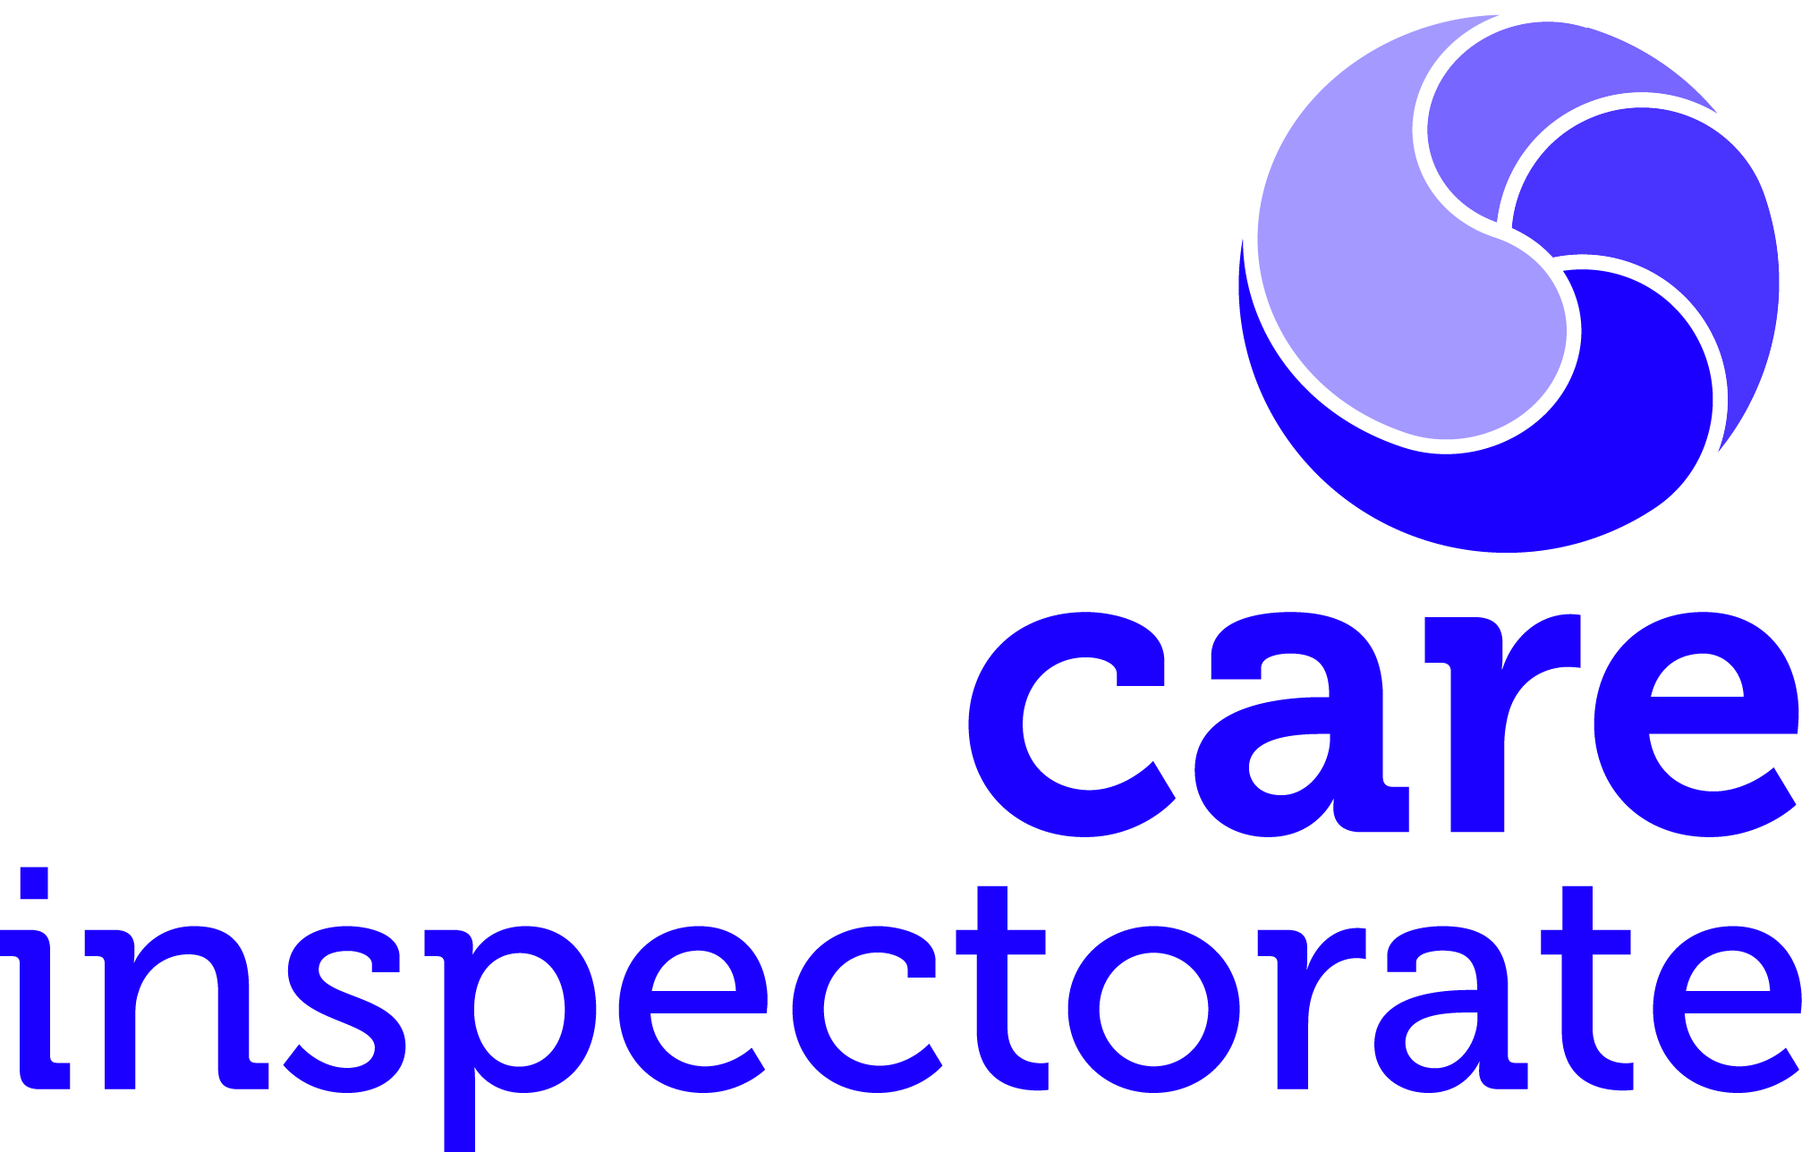
Care Inspectorate Inspector

Please note: Inspectors must have a practice qualification and have or gain a scrutiny and improvement award.

The main national practice qualifications are:
- BA Childhood Practice
- BA Social Pedagogy (University of Aberdeen)
- BA (Hons) Social Work (or equivalent)
- Postgraduate Diploma Childhood Practice
- SQA Professional Development Award Childhood Practice (360 credits at SCQF Level 9)
- SVQ Social Services (Children and Young People) at SCQF Level 9
- SVQ Social Services and Healthcare at SCQF Level 9
- SVQ 4 Children's Care Learning and Development at SCQF Level 9
- SVQ 4 Health and Social Care at SCQF Level 9

You must hold the Regulation of Care Award (Scotland) (ROCA) or gain the Professional Development Award in Scrutiny and Improvement (Social Services).

You may have one of the following awards:
- European Foundation for Quality Management (EFQM) Assessor Award as provided by Quality Scotland (if required).
- Public Service Improvement Framework (PSIF) Assessor Award as provided by Quality Scotland (if required).

Qualifications meeting requirements of other regulatory bodies:
- A qualification meeting the registration requirements of the General Teaching Council (Scotland), Nursing and Midwifery Council or the General Medical Council
- A qualification meeting the registration requirements for the following professional groups regulated by the Health and Care Professions Council, Occupational Therapists, Physiotherapists, Speech and Language Therapists, Practitioner Psychologists.
- Degree or Diploma in Community Education or equivalent as recognised by the Standards Council for Community Learning and Development for Scotland Approvals Committee

