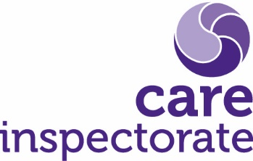
Joint inspection of services for children at risk of harm

Request for management reviews during joint
Inspection and other strategic scrutiny

Publication date: November 2021

Publication code: 005a

Requests for management reviews during joint inspections and other strategic scrutiny
During joint inspections or other strategic scrutiny, there may be times when members of inspection teams raise concerns about a particular child, young person or adult. In all instances, these concerns should be discussed verbally with the inspection lead or depute lead. If the inspection lead (or depute) decides to raise a particular issue (that is not a child or adult protection concern) with the partnership by requesting a management review, this form should be completed by the inspection lead (or depute). Note that if there are child or adult protection concerns, these should be raised using the addressing matters of serious concern form.
CI record sample number or session number (if available): | Summary of reason for requesting a management review and note of outcome

This form should be stored in the record reading folder of the relevant community planning partnership area in line with records keeping protocols.

Headquarters
Care Inspectorate
Compass House
11 Riverside Drive
Dundee
DD1 4NY

web: www.careinspectorate.com
email: enquiries@careinspectorate.com
telephone: 0345 600 9527

@careinspect

Other languages and formats

Copyright of Care Inspectorate 2023 