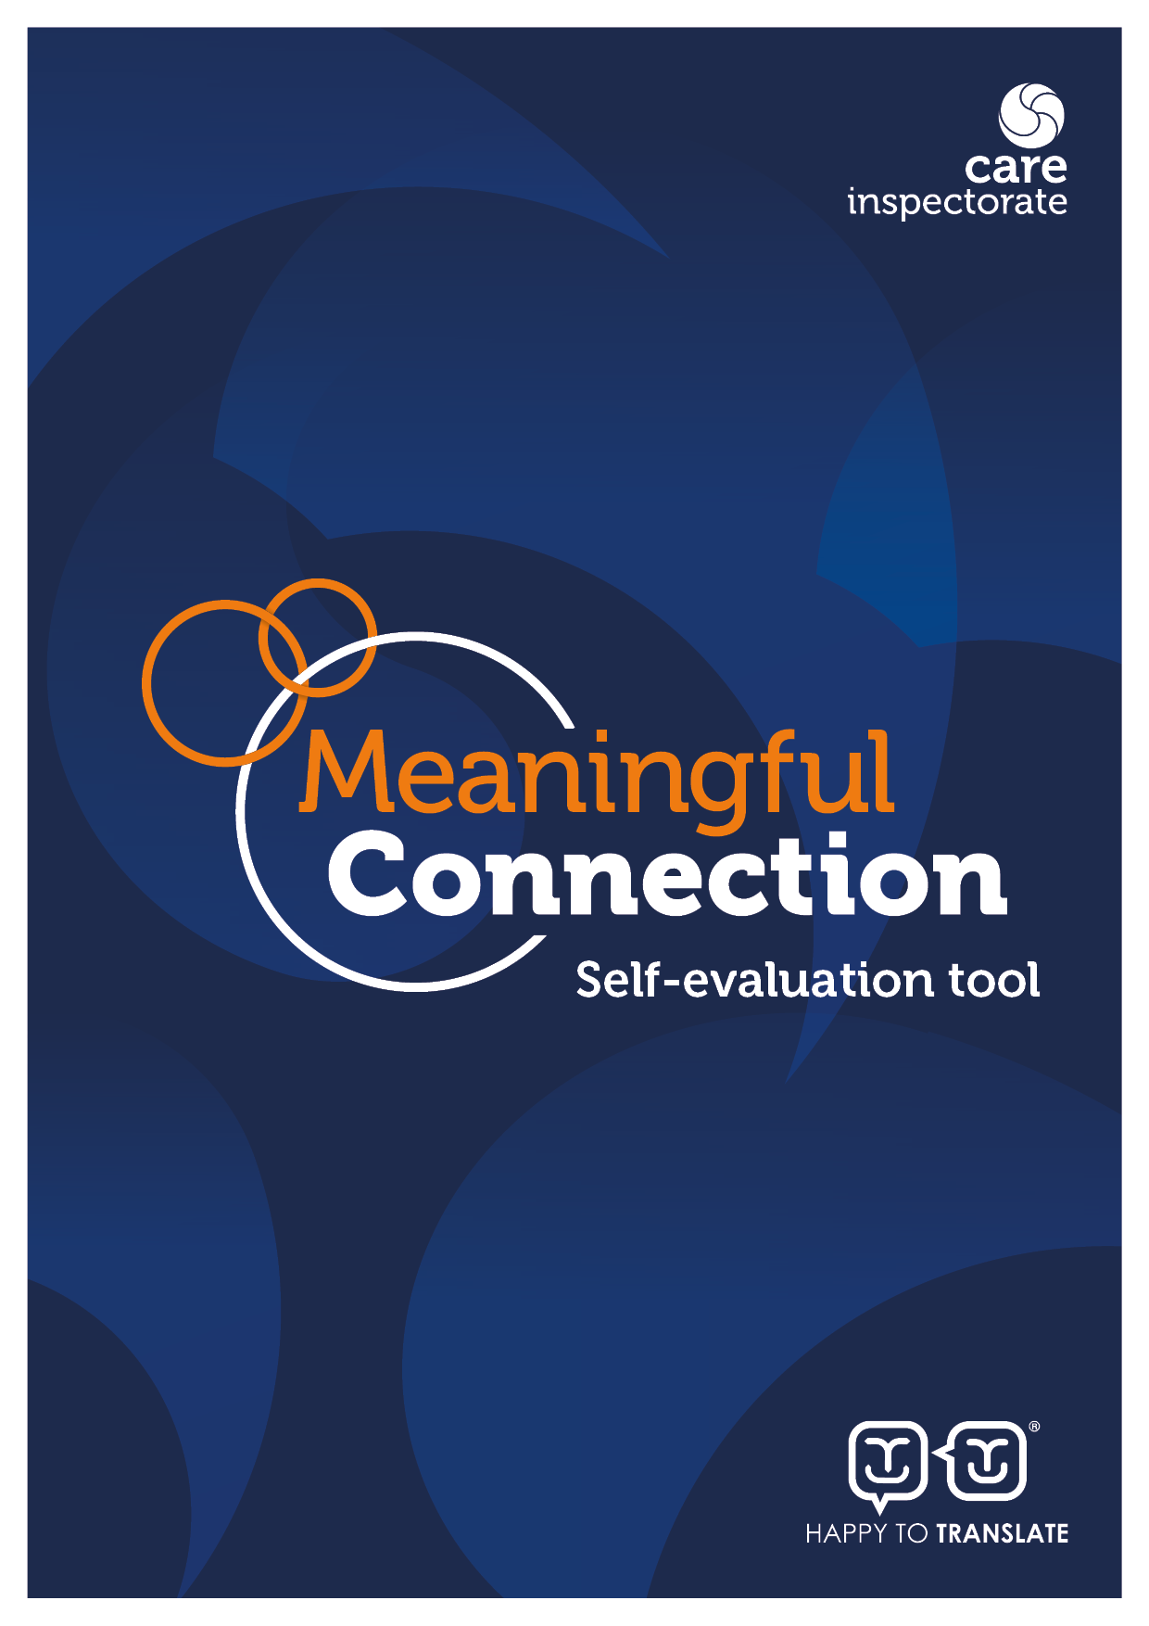
Self-evaluation tool: Meaningful connection in care homes
Introduction

This tool will help you to evaluate how well you are doing to support meaningful connection for people living in adult and older people’s care homes, and identify any areas where you want to improve. See appendix 2 for links to resources to support meaningful connection.

Meaningful connection – which may include connection with families and friends, other people living in the care home, staff, and the wider community - is essential to people’s emotional, mental and physical health and wellbeing, and is a fundamental human right. (See Appendix 2.) This tool is designed to help in your commitment to uphold and promote the rights and social needs of people who live in care homes. We know that when restrictions are placed on social connection, such as during an outbreak of infectious disease, this can create difficulties in decision-making when considering how to uphold people’s rights, maintain their independence and value their choices. Consideration may also be relevant when people’s own health conditions or circumstances change, which may prevent them from engaging with other people or participating in activities they previously enjoyed.

Acting on the results of this self-evaluation tool will contribute to promoting a wider culture of ensuring people experience positive meaningful connection and relationships they enjoy, both within and outside the care home. This will enhance individual identity and personhood. A culture for connection is one where the service as a whole, and each member of staff, is committed to ensuring that everyone living in the care home has the best opportunity to reach their potential, be valued as an individual, and maintain and develop relationships with people important to them. Being an active member of the community supports citizenship, while giving people opportunities to improve their health and wellbeing. We hope this tool will help you to identify key areas which can support people to experience connection that is meaningful to them, and ensure people get the most out of life.

Self-evaluation is best done by those who know the service. Find ways to include people experiencing care, their families, staff, or other stakeholders/professionals as appropriate for each question. We do not expect you to return this self-evaluation tool to us. This is part of your wider evaluation and improvement plan for your service and how you support improved outcomes for people. The self-evaluation toolkit can provide further guidance and ideas.

Three key questions help with self-evaluation:

1 How are we doing? This helps you to understand the impact of your service on the lives of people experiencing care.

2 How do we know? This helps you consider what evidence you have to show how good
you are. For each question, think about the best ways to gather this evidence. This could include:
- the views of people experiencing care and their families (consider the best ways of seeking the views of the people you support, especially if they experience sensory or cognitive impairments);
- the views of other stakeholders and professionals that interact with your service;
- direct observations of staff practice and interactions;
- performance or improvement data collected by you or others;
- reviewing documentation that evidences how decisions are made including risk assessments;
- improvement stories; and
- quality assurance activities such as benchmarking, team meeting discussions, focus groups, reviewed risk assessments/reviewed personal plans, achieved outcomes, activities plans and outings.

3 What are we going to do now?
This helps you to make specific plans to improve based on the first two questions, including changes you plan to test out and specific actions you are going to take.

Self-evaluation tool

The ability to identify what is working well, what is not working well and how improvements can be made is a strength. Using this information to develop and carry through an improvement plan demonstrates good leadership and management and is characteristic of an organisation that continues to develop to support the best outcomes for people.

The self-evaluation table gives you space to rate how you are doing against different statements, list the evidence you have to back up the rating, and the next steps to take. This is the rating scale to choose from.

1. Major weaknesses - urgent remedial action required
2. Important weaknesses - priority action required
3. Strengths just outweigh weaknesses
4. Important strengths, with some areas for improvement
5. Major strengths
6. Outstanding or sector leading

You do not need to complete the whole self-evaluation tool at one time. It may be helpful to select a section to focus on initially.

By the end of the questions, you will be ready to complete your improvement plan with specific dates and people responsible for carrying through each step. We have included an improvement plan template at the end of the document along with further information, useful links and resources which we hope will help you.

Date of self-evaluation: ________________________ Who led this self-evaluation? _____________________________________

Who else was involved? (Should include people experiencing care, family carers, staff, and external stakeholders.) ________________________________________________________________________

__________________________________________________________________________________________________________________

Creating a culture for connection | 1 | 2 | 3 | 4 | 5 | 6 | How do we know, what is our evidence for choosing this number?  (What do people / families / staff / stakeholders say? What is written down?) | What would we like to focus on to make this even better?
Staff know what people’s preferences and needs for meaningful connection are and reflect them in daily practice.

People experiencing care are supported to remain meaningfully connected to their families and friends.

Families and friends are welcomed and valued as equal partners in care, when this is what people want.

Families and friends’ inclusion is supported and facilitated and any barriers addressed.

People experiencing care have opportunities for a range of person-centred, meaningful activities which are diverse and creative, and support social interaction.

Staff take time to build warm, supportive and positive relationships with people experiencing care.

Staff understand and value the importance of meaningful connection to support people’s personhood and enrich everyday life.

People with specific communication needs and/or cognitive impairments are enabled and supported to participate in ways that suit them best.

The physical environment and layout of the home facilitates social interaction and the development of peer relationships.

People have a range of options for where to spend their time.

People are supported to stay connected to families, friends and the wider community through thoughtful, person-centred use of appropriate technology.

The care home has strong links with the local community, and people have a range of opportunities to be involved in and feel part of the wider community.

Visiting and outbreaks | 1 | 2 | 3 | 4 | 5 | 6 | How do we know, what is our evidence for choosing this number?  (What do people / families / staff / stakeholders say? What is written down?) | What would we like to focus on to make this even better?
Visiting is unrestricted and in line with current guidance.

Visitors feel welcome and visits are a positive and meaningful experience for those involved.

People who do not have regular visitors still have opportunities for meaningful connection.

If any temporary restrictions to visiting and/or periods of isolation are needed, people’s psychological wellbeing is sensitively supported, and their rights protected.

Any temporary restrictions to visiting are clearly communicated to everyone, including the expected end date.

In an outbreak situation, staff are aware of, understand and support people to follow current guidance.

Other items you think would be useful to evaluate.

Appendix 1: Improvement plan template
The care service manager retains overall responsibility for completing and reviewing the improvement plan. This should be in a format you can share. You should review this plan regularly and make the information accessible so you can share it with the people who experience your care, their families, staff, and others involved with your service.
Outcome  What do we want to achieve? | Actions  How are we going to do it? | Timeframe  When will this step be completed or next reviewed? | Person responsible  Who is responsible for completing this step/action? | Leave this column blank until you review the improvement plan.  Date of review:  Is the action complete? If not, what is the next step?

Appendix 2: Useful notes, resources and further reading

Promoting choice and human rights

The National Health and Wellbeing Outcomes Framework (2015) states, ‘A human rights-based approach means that all forms of discrimination must be prohibited, prevented and eliminated. It also requires the prioritisation of those in the most vulnerable situations who face the biggest barriers to realising their rights.’ Many who live in care homes have advanced needs, and due to many factors, their voice is often not heard. During the pandemic we have all witnessed first-hand how vulnerable care home residents and their families have been, and how people’s human rights for meaningful connection have been severely challenged.

Upholding people’s human rights, and ensuring choice is promoted, is integral to ensuring responsive, person-centred care. The five principles of the Health and Social Care Standards (dignity and respect, compassion, be included, responsive care and support, and wellbeing) are fundamental to this approach.

Useful resources

Self-evaluation tools and guidance for care homes for adults and older people (careinspectorate.com)

Health and Social Care Standards

Health and Social Care Standards on visiting - guidance for providers - edit.pdf (careinspectorate.com)

Open with Care guidance

Restoring Relationships (TIDE)

Guide for providers on personal planning

Guidance on using technology and digital devices

Come on in - Staying connected - Leaflet

Skills for Care: Supporting Personal Relationships

Care Inspectorate literature review on meaningful connection

We recommend using the Model for Improvement to ensure that the changes you make will lead to the improvements you intended. You can read more on this in Starting your improvement journey.

Other links and resources that you might find useful are:

  - Care Inspectorate Self-evaluation for improvement – your guide
  - Care Inspectorate Quality Framework for care homes for adults and older people
  - Institute for Healthcare Improvement – how to improve

