Technology Enabled Care Programme
Test of Change for Service Innovation 2019/20
The Digital Health & Care Supporting Service Transformation Delivery Plan was published earlier this year. It articulates a strategic aim:
“To put in place a process that identifies innovative solutions, products and approaches that address key national priorities and can be adopted at scale into mainstream ‘business as usual’”
It defines a deliverable for Tests of Change as follows:
“One call in year for Tests of Change and nurturing of candidate services through the pipeline.”
Last year we began our work to establish the Tests of Change component of the Service Innovation Pipeline. In this year’s call for proposals we are seeking applications for Stage 1 tests to replenish the pipeline (illustrated below).

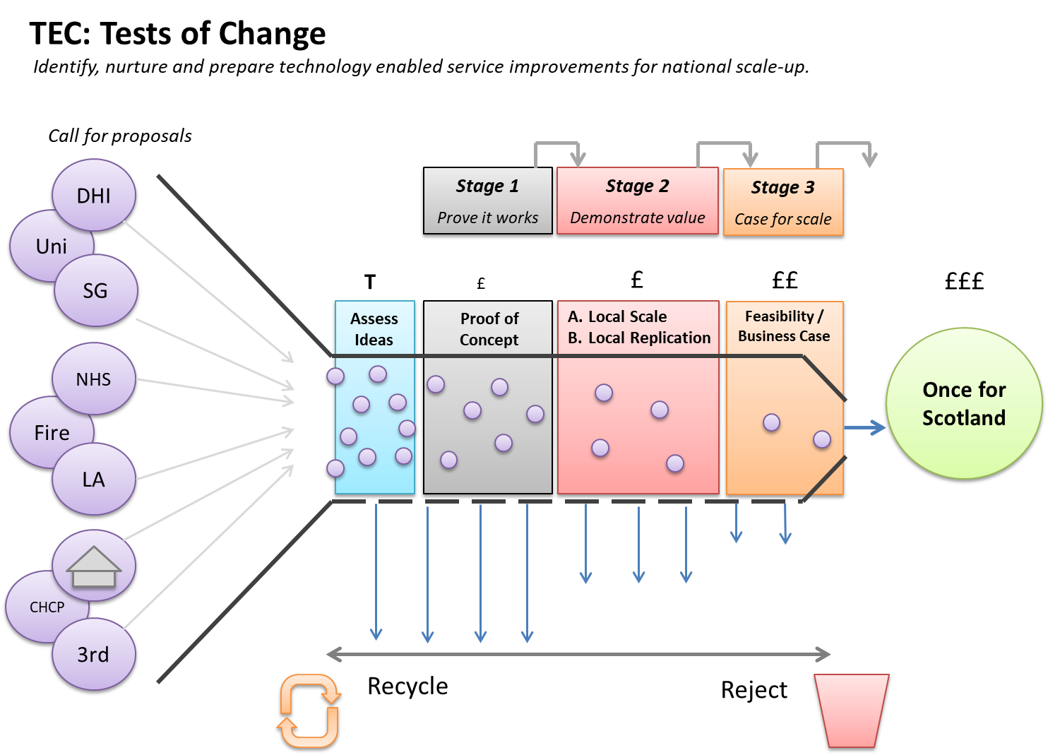

Current test participants will be invited to apply for Stage 2 or Stage 3 funding where appropriate.

Test description
Stage 1 Test of Change
‘Proof of Concept’
- A new idea or an idea applied successfully elsewhere
- Demonstrates that a proposed technology enabled pathway is possible in a specific locale with a small number of users
- Is small-scale, low cost and quick to implement
- Uses Plan, Do, Study, Act (PDSA) cycles to record and inform progress
- Provides quick insight into what works / does not work and why
- Informs if the idea merits further investment.

Qualification
- Applications are open to any NHS Board, Integration Authority, Housing, Independent Care or Third Sector organisation.
- Applications may be made by an individual organisation or as a multi-organisation collaboration provided a single organisation takes the role of ‘Lead Partner’.
- Provided that one of the aforementioned organisations take the lead role, collaborations with Academia and Industry are also welcomed and encouraged.
- The aim of an application must align with the overarching TEC Programme aim which is to support more citizens to make greater use of technology to manage their own health and wellbeing at home and in the community.
- Applying organisations are expected to be signatories to the Digital Participation Charter (or actively considering becoming signatories). https://digitalparticipation.scot/charter
NOTE: A test of change should seek to demonstrate measurable improvement in outcomes either directly to individuals or indirectly through improved service design and delivery. Applications that are not explicit about the improvement they are intended to demonstrate will be rejected.
Additional information:
The test of change programme has to date received a wide range of proposals and it is hoped that this year will be no different. To assist in the generation of suitable ideas the programme has identified some current focus areas. These are detailed below and are not intended to exclude proposals for tests that support delivery of the programme aim in other ways. There will be a degree of overlap in a number of these areas as they are not mutually exclusive.
- Services that support improved delivery of mental health services and in particular mental health services for young people
- The introduction of technology enabled services that help to reduce waiting times
- The introduction of new TEC enabled pathways that better support people living with Long Term Conditions including service applications to support prevention, early intervention and supported self-management
- Approaches and interventions to support the social care reform priorities
- Housing sector service redesign to better support individuals to remain at home with reduced reliance on statutory services
- Third sector delivered health and care service pathways / interventions
- Support for carers / young carers
- Pathways / interventions to support difficult to reach communities including traveller, homeless, asylum seeker and victims of abuse communities
- Pathways / interventions to support addiction and recovery support services

Please submit completed applications to:
NSS.TEC@nhs.net by the 12th August 2019

Yours faithfully,
Scott Henderson
Tests of Change Lead
Technology Enabled Care Programme
NSS.TEC@nhs.net

Stage 1 Test of Change Application

Use this form if:
- You have a clear and objective performance improvement aim
- You have a clear rationale for how your improvement will be delivered
- You have access to the underlying Technology or platform needed to run your test
- You can conduct your test within 3 x 30 day cycles and within your requested funding.

Do not use this form if:
- You have not already secured access to the underlying technology (e.g. a service solution or platform) at the time of application
- You are uncertain of the support from one or more key stakeholders
- You need to formally recruit anyone, other than service users, to run your test
- Your test relies on items that need to be procured and will take more than 3-4 weeks to be delivered.

Information for applicants
Stage 1: £3k up to a maximum of £18k
90 day rapid test of change through three 30 day cycles.
Stage 1 funding is intended to support improvement across a wide range of TEC service processes and pathways. These may be service development focused where tests focus on “new to you” technology, applying familiar technology in a different way or at a different time in a pathway, or testing out a model which other partnerships have found successful. They may also be about improving service support processes; those activities that help or enable service users and service delivery colleagues to implement TEC services effectively.
Requirements
Applications for Stage 1 funding must be made by completing the attached Application for Funding form. To qualify for consideration applications must meet the following requirements.
- The technology or TEC service involved is citizen focussed.
- A clear and objective Improvement Aim is articulated.
- A clear rationale for how the improvement will be delivered is demonstrated.
- A description of the expected benefits and how these will be measured is given.
- By submitting an application, applicants are confirming that they are in a state of readiness to initiate their proposed test of change and conclude learning by the end of March 2020. Specifically, an application confirms that:
  - The underlying technology is already in place
  - The appropriate resources are (or will become) available to complete the process within the allotted time
  - Organisational and stakeholder support for the test has been secured.
- Funding sought for equipment is only for low cost “non-standard” equipment or associated additional technology costs (i.e. funding for equipment should not be used to procure basic items required to undertake the role such as desktop computers, mobile phones etc.).
- Funding sought for staff time is project specific only e.g. backfill, clinical or other leadership, analytical support, improvement support or project support for duration of improvement project. Funding will not be given and may not be used for operational costs, nor for the procurement of staff time that is reliant on any form of recruitment process.
- The proposed change must not already be supported via current TEC programme funding or other funding stream.

Application for ‘Stage 1’ Test of Change Funding
PART 1: Applicant and Test Information
Applicant name and position
Applicant email and telephone contact details
Organisation for which this application is made
Title of the Test
Signed up to the Digital Participation Charter?
Amount of funding sought
Details of what funding is for
Intended start date | (no later than 18th October 2019)
Contact details
Bank details if your organisation is out with Health and Social Care

PART 2: Improvement Rationale
1. Improvement Aim Statement
What do you expect to be better after this change is made? (Be clear about your aim. This is not about describing your solutions. It is about the difference your solutions are intended to make. Be objective in what you want to achieve using 2-3 sentences max).
Hint: Six common overall improvement aims are Safety; Effectiveness; Person-centred; Timeliness; Efficiency and Equity. Your aims should describe what will:
- increase or reduce; be accelerated or delayed; be avoided, prevented or eliminated; or be added that wasn’t there before.
Examples:
- We aim to reduce time taken up by care home visits by 3 hours a week while maintaining the quality and safety of support given to care home staff and residents
- We aim to reduce the time taken to diagnose Hypertension in Primary Care settings by 14 days
- We aim to increase the same-day discharge rates for xxxxxx service by 20%
- We aim to reduce unnecessary call-outs for xxxxx by 18%
- We aim to reduce xxxxxxx service’s failure to attend rates by 10%

2. Problem Statement
Describe the “presenting problem” in no more than 4 bullet points. For example, say what is happening, why it is happening, who is being affected and what the consequences are.
1.

2.

3.

4.

3. Analysis of current situation
What have you learned about the problem(s)?
What meaningful information have you gathered to support your analysis, have you isolated the root-cause? Demonstrate, through data if possible.

4. Proposed Test of Change
Outline the key changes that you plan to test which aim to improve care. Which parts of the current working practice will change in what way and to what effect?
1.

2.

3…etc.

5. Anticipated Outcomes and Measures
Outline the Improvements you expect to see as a result from planned changes / interventions). List the measures you propose to capture to demonstrate that you are making progress. Include qualitative and quantitative as appropriate. Start by stating your key outcome measure and then state what process measures / balancing measures you will use.

6. Stakeholders
1) Who are the delivery team (Change Lead, situation/ clinical expertise , sponsor?)
2) other key stakeholders involved

Please indicate % confidence that the test of change you propose is feasible within the allotted 90 days__________

If you have low confidence, review the scale and scope of your test.

